Lab 4 – Making threat models

Lab Intro
In this lab session you will focus on constructing a threat model for the assessment system: Scoops2Go. You will do this working within your development teams by: (1) applying the CMU’s Hybrid Threat Modelling Method, also known as hTMM; (2) recording and documenting these requirements using the GitHub Flow (from week 2).

Learning Outcomes
By the end of this session, you will be able to:
- Describe what threat modelling is, who should do it, and why it's important.
- Compare different threat modelling techniques.
- Construct a threat model for the assessment system – Scoops2Go.

Resources
- Lecture 4 – Making Threat Models
- The Security Cards. The facilitator will provide you with print outs. There is also an online version available here: Home | The Security Cards: A Security Thrzz eat Brainstorming Kit.

Recap: Threat Modelling
You will recall two important definitions from the lecture:
- Threat Something unpleasant or harmful that could occur (relating to a given technical system).
- Threat modelling Identification of threats that could impact a given technical system.

Additionally, you will remember that threat modelling is a design activity that generally involves asking the following 4 questions:
- What are we working on?
- What could go wrong?
- What are we going to do?
- Did we do a good job?

And finally, you will remember that whilst there are many distinct threat modelling methods, we will be focusing on and applying a leading method in todays lab: CMU’s Hybrid Threat Modelling Method (hTMM). This lab worksheet will therefore walk your through the 5 main steps of hTMM:
- Identify the system.
- Apply “The Security Cards” based on developers’ suggestions.
- Removes unlikely or unrealistic threat actor personas.
- Summarizes the results of the analysis.
- Moves on to a formal risk assessment.

Step 1: Identify the System
As you should be aware by now, Scoops2Go is the system you will be developing on this module (as a part of 1CWK100). The first step of applying hTMM is “identifying this system”. This basically means gathering as much information and documentation about the system as we feasibly can. You should therefore review the following documents in your development team:
- The example functional requirements you were given for Scoops2Go (see the worksheet from last week, i.e., lab 3).
- The security requirements you documented for Scoops2Go last week (ideally these will have been added to your shared GitHub repository).
- The C4 diagrams provided below. Context (level 1) and Container (level 2) diagrams have been provided.

C4 Diagrams for Scoops2Go
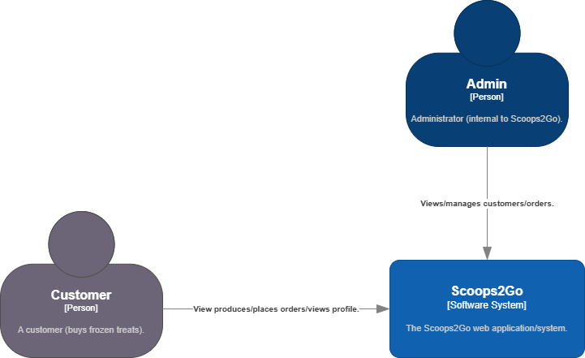
Figure 1: Context (level 1 diagram) for Scoops2Go.
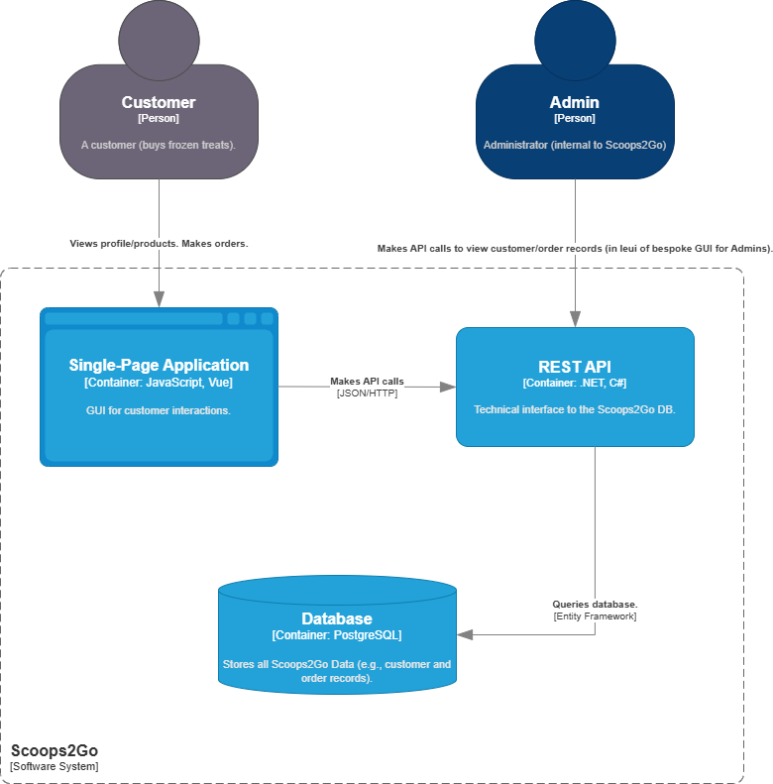
Figure 2: Container (level 2 diagram) for Scoops2Go.

Step 2: Apply “The Security Cards”
The next step is to apply “The Security Cards”. You will recall from the lecture that these cards serve as useful prompts when answering the “What could go wrong” question. First, ask the facilitator for a set of “The Security Cards”. Then, apply the security cards in your development team as follows:
- Familiarise yourself with the security cards (a nice way of doing this is if each team member explains a security card of their choice to the rest of the development team).
- In your development teams, rank the security cards by order of importance with respect to the Scoops2Go system. You should rank cards within the same dimension (so have 4 lists in total, 1 list ranking adversary motivations, another list ranking adversary resources, etc.).
- The two previous steps should have got you thinking about the threats Scoops2Go faces. To complete this part of hTMM, have an initial go at documenting these threats using Table 1. At this stage, we’re interested in quantity just as much as quality, so come up with as many as you can and don’t worry too much about how realistic they are for now!

Table 1: An initial list of threats facing Scoops2Go (generated using “The Security Cards”).
Threats facing Scoops2Go
Example #1: Motivated by revenge or malice, a disgruntled employee might use their insider capabilities to expose the sensitive personal data of customers.
Example #2: An adversary with technical expertise might take advantage of an SQLi vulnerability to retrieve customer email addresses. They might then use this information to craft a phishing email designed to trick customers into giving them money (i.e., a multi-phase attack resulting in financial loss).
Example #3: A group sponsored by a nation-state might launch a highly sophisticated multi-phase attack against Scoops2Go to wreak havoc with another nation’s frozen treat delivery infrastructure.
Example #4 Financial gain: a cyber criminal might perform brute-force attack against the login page to gain unauthorized access to customers account, so they access the payment details such as bank details, upi id, etc.
DDOS attack: Attacker can launch a Distributed Denial of Service attack by flooding the Scoop2Go servers with excessive traffic. This could make website unavailable to legitimate customers, resulting in revenue loss and reputational damage.
Malicious intent: Motivated by curiosity or malicious intent, a technical skilled attacker might exploit an insecure API endpoint to modify order details or pricing information, potentially causing financial loss to company.
Financial fraud: An attacker might exploit adversary relate to contributing organize crime adversary and corporate advisory and also drain assets, sell user data, sabotage the competitor’s market and manipulate the market.
Privilege escalation: If a normal employee got the highest level of access such as privileged access, then I could be an issue in the internal infrastructure of Scoop2Go.
Reputational damage: The competitors can influence the normal employees of Scoop2Go for performing internal attacks to the system which can cause great financial as well as reputational loss which also include tampering the product listing to the organization.
Ransomware attack: A financially motivated cybercriminal might deploy ransomware through a phishing email or infected attachment, encrypting Scoops2Go’s order database and demanding payment in exchange for restoring access, causing operational disruption and financial loss.

Supply chain compromise:
An attacker might compromise a third-party vendor (such as a payment gateway or delivery partner API) and use that trusted integration as an entry point to infiltrate Scoops2Go’s internal systems and steal sensitive customer data.
Session hijacking:
A technically skilled adversary might exploit weak session management or unsecured public Wi-Fi connections to hijack active customer sessions, gaining unauthorized access to accounts and personal information.
Credential stuffing attack:
An attacker could use previously leaked username–password combinations from other data breaches to perform automated credential stuffing attacks against Scoops2Go’s login portal, leading to unauthorized account access.
Data backup compromise:
An adversary might target unsecured cloud backups of Scoops2Go’s customer and transaction data, deleting or altering backups to prevent recovery after an attack, increasing the impact of a security breach.
Insider data theft for financial gain:
A contractor or temporary employee with legitimate system access might copy customer databases and sell them on the dark web for profit, resulting in legal and reputational consequences.
DNS spoofing attack:
An attacker might perform DNS spoofing or cache poisoning to redirect customers from the legitimate Scoops2Go website to a fake website designed to steal login credentials and payment information.
Mobile application exploitation:
If Scoops2Go offers a mobile app, an attacker might reverse engineer the application to discover hardcoded API keys or encryption flaws, enabling unauthorized access to backend systems or sensitive customer data.

Step 3: Remove Unlikely or Unrealistic Threat Actor Personas
The next step is to filter down the threats you have documented (in Table 1). In hTMM you do this by thinking about the threat actor (i.e., the person that would be attacking your system, or the Persona non Grata). If you are struggling to think of a threat actor, or it seems unlikely that a threat actor you can imagine would actually exist in reality, then you should remove it from your list at this point. For instance, the following example threat would be filtered out at this stage as it is unlikely a nation-state level adversary would want to attack Scoops2Go due to diplomacy or warfare:

A group sponsored by a nation-state might launch a highly sophisticated multi-phase attack against Scoops2Go to wreak havoc with another nation’s frozen treat delivery infrastructure.

Discuss the threats you identified within step 2 in your development teams. Filter out the threats that seem unlikely and overly unrealistic to create a refined list in Table 2.

Table 2: A refined list of threats for Scoops2Go.
(Refined) Threats facing Scoops2Go
Example #1: Motivated by revenge or malice, a disgruntled employee might use their insider capabilities to expose the sensitive personal data of customers.
Example #2: An adversary with technical expertise might take advantage of an SQLi vulnerability to retrieve customer email addresses. They might then use this information to craft a phishing email designed to trick customers into giving them money (i.e., a multi-phase attack resulting in financial loss).
Financial gain: a cybercriminal might perform brute-force attack against the login page to gain unauthorized access to customers account, so they access the payment details such as bank details, upi id, etc.
Privilege escalation: If a normal employee got the highest level of access such as privileged access, then I could be an issue in the internal infrastructure of Scoop2Go.
Reputational damage: The competitors can influence the normal employees of Scoop2Go for performing internal attacks to the system which can cause great financial as well as reputational loss which also include tampering the product listing to the organization.
Malicious intent: Motivated by curiosity or malicious intent, a technical skilled attacker might exploit an insecure API endpoint to modify order details or pricing information, potentially causing financial loss to company.

Step 4: Summarise the Results of the Analysis
The next step is to formalise the results of the analysis. In the hTMM, this involves categorising the remaining threats using another threat modelling method known as STRIDE, in which:

- The S stands for Spoofing and refers to threats that violate authenticity (i.e., when a threat actor pretends to be someone they are not).
- The T stands for Tampering and refers to threats that violate integrity (e.g., a threat actor might delete or alter a customer record).
- The R stands for Repudiation and refers to threats that violate non-repudiation (i.e., auditability, or when a threat actor does something that cannot be traced back to them).
- The I stands for Information Disclosure and refers to threats violate confidentiality (e.g., when a threat actor obtains customer records containing sensitive personal data).
- The D stands for Denial of Service and refers to threats the violate availability (e.g., any kind of denial-of-service attack).
- The E stands of Elevation of Privilege and refers to threats that violate authorisation (e.g., Broken Object Level Authorisation).

Additionally, we will also suggest some broad actions for dealing with the threats at this stage:

- Mitigate. Make it harder for a malicious actor to take advantage of this threat.
- Eliminate. Remove the feature of interface that creates the threat.
- Transfer. Have someone else manage the feature/interface (use a third-party service).
- Accept. Recognise that the time to mitigate/eliminate the threat undermines the project.

With reference to the above definitions, work in your development teams to reformat your threats into Table 3.

Table 3: A summarised list of threats for Scoops2Go.
Adversary | Motivation | Method | Impact | Type | Req. Action
Disgruntled employee | Revenge or malice | Might use insider capabilities to access personal data with malicious intent. | Personal data exposed | Information disclosure | Mitigate – Using a strict authorisation scheme
Cyber criminal | Money | Might use SQLi to retrieve personal data and use this to craft a phishing email. | Personal data exposed, reputational harm | Information disclosure | Mitigate – Using an Object Relational Mapper
Attacker | Malicious intent | SQL injection, DDos attack | Financial loss, Personal data loss | Tampering | Mitigate – Using an Object Relational Mapper
Competitor | Reputational damage | Employees having higher privileges can create system backdoors affecting the system design | Personal data loss | Tampering | Restrict the level of privilege given to the normal users.
Insider | Financial froad | Steals and sells customer database | Legal issues, reputational damage | Information Disclosure | Mitigate – Data encryption, access logging
Attacker | Malicious intent | Hijacks user sessions over insecure networks | Unauthorized account access | Spoofing | Mitigate – Use HTTPS, secure cookies, session expiry

Step 5: Moving onto Formal Risk Assessment
Note: Time in the lab might be running out at this point. Don’t worry – this next section can be completed asynchronously if needed, but it will be a good idea to discuss your approach in your development teams before leaving the lab if you intend to go down this route. It is important that you complete this section (ideally before next week) as it feeds directly into your assessment.

You should now have a list of threats that are relevant to Scoops2Go (from the previous tasks). At this point, we are therefore going to conclude our threat modelling and package up / share our work (so that it could feasibly be viewed by a risk assessment team). Select one person from your development team to add the threat model to your shared development repository using the GitHub Flow (from week 2) – feel free to help them out of course:

- Follow the instructions from the week 2 lab if you need to (see the “Raising a Pull Request” section).
- Name your branch: add-threat-model (corresponds to step 6 if you’re using the instructions from week 2).
- Create a ThreatModel.md file and put your threat model into it (instead of step 9 if you’re following the instructions from week 2). Important Hint/Tip: Use Table to Markdown to generate markdown code for your completed table 3, then simply copy and paste it into the file.

Before the pull request is merged in, every team member should have the opportunity to add comments to the pull request (including the person who raised it). You might simply want to say “approved by firstName lastName”. However, you might also want to be a bit more critical. Each team member should think about one of the following points and add a comment to the pull request:

- Have any threats been missed?
- Are the strategy/mitigations that have been considered appropriate?
- Is the threat model clear, well documented, and easy to understand?

These comments should be actioned by making further commits onto the add-threat-model branch and including them in the pull request if necessary. After every team member has had a chance to comment on and approve the pull request, it should be merged into the main branch. – It is up to you and your team exactly how you do this.

Appendix A: Hints & Tips
Feeling stuck? Consider the hints and tips below:
- If you’re struggling with step 2, simply try picking a random security card from each dimension and coming up with a threat that fits this scenario. The goal with step 2 is to think divergently, so it doesn’t matter how silly your threat seems.
- If you’re struggling with step 2, why not try experimenting with generative AI and using Microsoft Copilot to help you come up with some additional threats.
- For steps 3 and 4, some common threat actors, or Persona non Grata, include:
  - Cyber criminals.
  - Business competitors.
  - Insiders (e.g., disgruntled employees).
  - “Hacktivists”.
  - Nation States.
  - Organised crime groups.
  - “Script Kiddies”.
  - Etc.
- For step 5, Use Table to Markdown to generate markdown code for your completed table 3, then simply copy and paste it into the file.

